**Airline Travel - Is It Safe?**

Due to news in current events, many media outlets have been discussing airline travel and whether it is still safe to travel through the air. Airline travel is one of the most convenient ways of getting from point A to point B. Travelers that use airlines range from business executives on their way to making a deal to a family of four taking a vacation. Therefore, it is essential that travelers have confidence that they are safe when they take to the skies. We decided to look at some of the numbers out there and get down to the truth.

**Is there an increase in fatal airline accidents over the years?**

We compared the number of fatal airline accidents from 1946-2021 to the number of fatal airline accidents from 1985 to 2014. We saw a significant decrease in the number of fatal airline accidents. This means that the chances of a flight ending in a fatal accident has decreased dramatically even in the modern age. Airlines value your business and, to value your business, they need to value your safety. The industry takes lessons from its history so that you can have confidence in your future air travel.

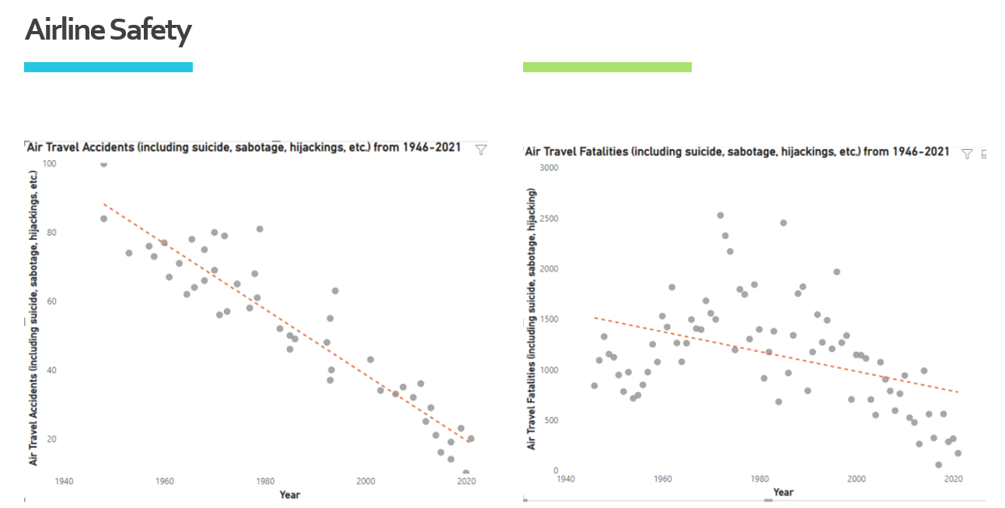

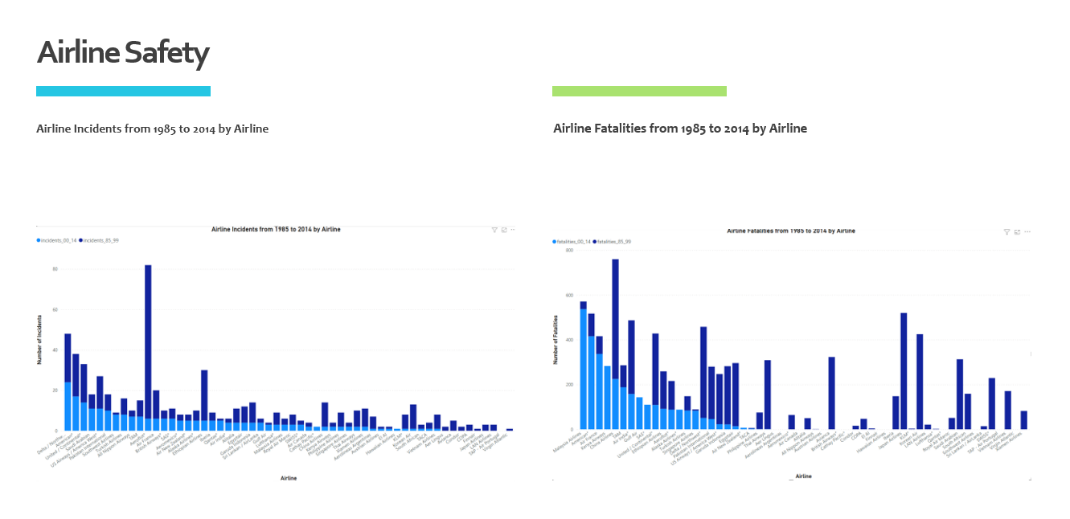

**Why does aviation mishaps gain so much attention?**

A main reason about the media hype and public buzz on airline catastrophe is the  risk perception. Airlines accidents grab our attention, induce fear, and tend to stick in our minds, giving us the false impression that these events are common occurrences no matter how infrequently they happen.

Part of the perception could be the scale, since one airplane crash can cause hundreds of lives; and the other part could be because in air travel, safety is completely under the flight crew and airlines' control with nothing much to do by the passengers.

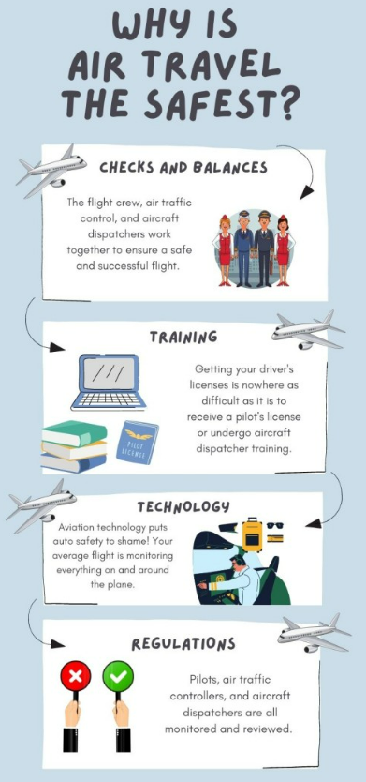

**Conclusion**

Aside from the number of checks and balances and regulations that airlines and those that work on them need to abide by, airplanes are a marvel of modern technology and engineering. Commercial airplanes have to abide by strict safety standards regardless of the ticket class that the passengers are sitting in. As technology in the industry has advanced to have passenger safety as a principal consideration, airplane seats can withstand 16 times gravity’s force. These seats are also fireproof and do not emit toxic fumes if they were to catch on fire. So, passengers sitting in even the cheapest seats could rest assured knowing that the seats that they own are the safest in the industry.